EM Spectrum images

Tuesday, December 10, 2013

11:42 PM

Machine generated alternative text: Penetrates
Earth
Atmosphere?
Wavelength
(meters)
THE ELECTROMAGNETIC SPECTRUM
10-10
About the size
Buildings Humans
Honey Bee
Molecules
Atoms
Atomic Nuclei
iO 10-2 1o-
Uftravkie
— ‘_________________.__—.I_.-—---——— .7
.5x10 10-8
h /
I Gamma Ray)
1 0-12
Frequency
(Hz)
Pinpoint Protozoans
I I I I I
I I ¿ I ¿
iO 108 1012 1015 1016 1018 1020
Temoerature
! I I

Machine generated alternative text: THE ELECTRO MAGNETIC SPECTRUM
Wavelength
(metres)
Radio Microwave Infrared Visible Ultraviolet X-Ray Gamma Ray
I I I I I I
iO 102 lo6 lo8 lOE10 1012
Frequency
(Hz)
I I I I I I
. , I I I I
1012 1015 1016 lOIS 1020

Machine generated alternative text: gamma ray ultraviolet infrared radio
4 - - b
X-ray visible microwave
‘‚
shorter wavelength longer wavelength
higher frequency ______ lower frequency
higher energy lower energy

Machine generated alternative text: Size a? wavelength
In nanometecs mm
0— Iiorter waeelengtns
Gamma ray
Ultra- Infrared
violet
II
Microwave
iX lO nm
(1 centimeter)
Longer wavelengths —0
‘adio
iX 10’ nm
(1 meter) \
.
Houseflies
44 ii mn (

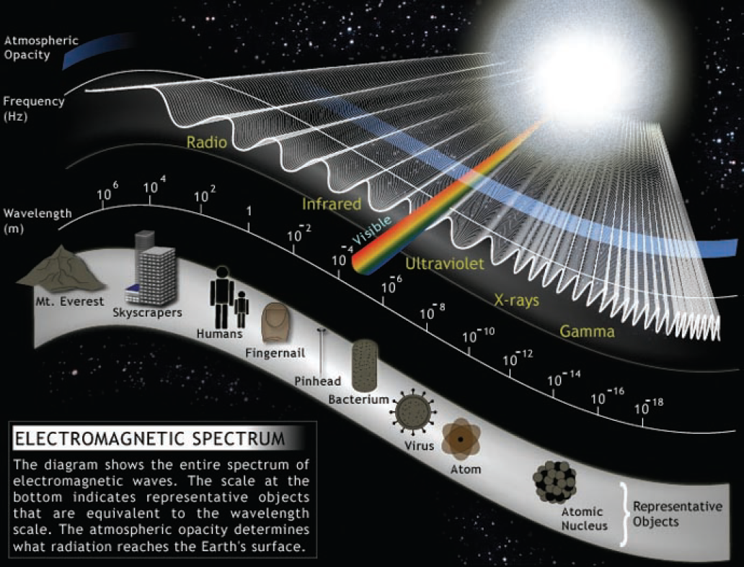

Machine generated alternative text: .—‘ j
.—.
‘... .,
.
.1
AM radio
Amateur
radio
Aircraft
communication
Microwave
oven
TV Remote
Control
Night vision
goggles
UV light
from the Sun
Airport security
scanner
PET
scan
Terrestrial
gamma-ray
flashes
Li
>
¿3
E
E
(9

Machine generated alternative text: Microwave ovens work by generating
mIcrowaves that causes the water molecules
In food to vibrate very quickly, with the result
that the food heats up rapidly. The wavelength
of waves in a microwave oven Is about 11 cen
timetres - about the width of your hand.
phone Microwave ovens Radar
Radio waves and microwaves pass through the Earths atmosphere and ca
surface. Molecules in the Earth’s atmosphere absorb many wavelengths at
Telescopes worliing in these bands are put on top of high mountains. Seve
space to avoid the problem of the atrmosphere completely. Optical telescc
This reduces the “twinkling we see from the stars at night, which is causa
far-ultraviolet and IC-rays have to be put into satelbtes as the atmosphere
space hitting our atmosphere produce a shower of blue Ight Special optl4
HESS telescope in Namibia works in this way to indirectly detect gamma r.
and from black holes in distant galaxies. Telescopes that detect gemma-ra
Waveienqths
(in metres)
(— longer
S.
is
nd.
at
up
rt
up
10 102 101 1 101
field
H ou se
10.2
Cricketball
10’s
How do radio
astronomers
use the
electro
magnetic
spectrum?
10’s
Honey bee
10’s
Point of a needle
106
Cell
Bacteria
108 10•
he
10-lo
Microwaves
At
cry day when we listen to
or use cell phones. Radio waves
• wavelengths than light waves.
ad by your FM radio at a frequency
:ycles per second (100 MegaHertz),
f about 3 metres.
Aircraft and SWiG
1h
w
u
ait l
iint o
u.,
Raid AM Radio
FM Radio and TV’
uen
Frequency
(waves per seco’
E- lower
infrared
Visible
Ultraviolet
X-rays
Gamme
We cannot see
Light that we can see is in the visibl, part of
If you stay in the
X-rays have so much energy and such a
Ganmia rayi
Infrared waves,
the electromagnetic spectrum and consist of
sun too lonq, your
short wavelength that it can go through
and can thei
but we can feel
its warmth on
our skin when we
red, orange, yellow, green, blue, Indigo and
violet. This makes up a very small part of
the electromagnetic spectrum. Their wave-
skin is burnt by
the ultraviolet
waves in the
your flesh, but not through your bones,
because the bones contain a lot of
calcium. That is why doctors can use
in metals, st
‘jwiis. Doct
gamma
sit in the sun,
length is a little under a millionth of a metre.
spectrum.
IC-rays to look at bones in your body.
. will cl
4-.
Light bulb
Ultraviolet light
X-rays _‘1
t
1013
1015
1016 1017
I
1018
10 106 10
loa 10 1010 10” 1012
1014