**Close Reading**

**Annotation Symbols**



This is an **important detail or fact**.

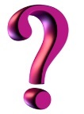 This **word is** **important**.

 I have a **question** about this.

 This is **interesting** or **surprising**.

I have a **connection**. (T-T, T-S, T-W)

E This is my **evidence**.

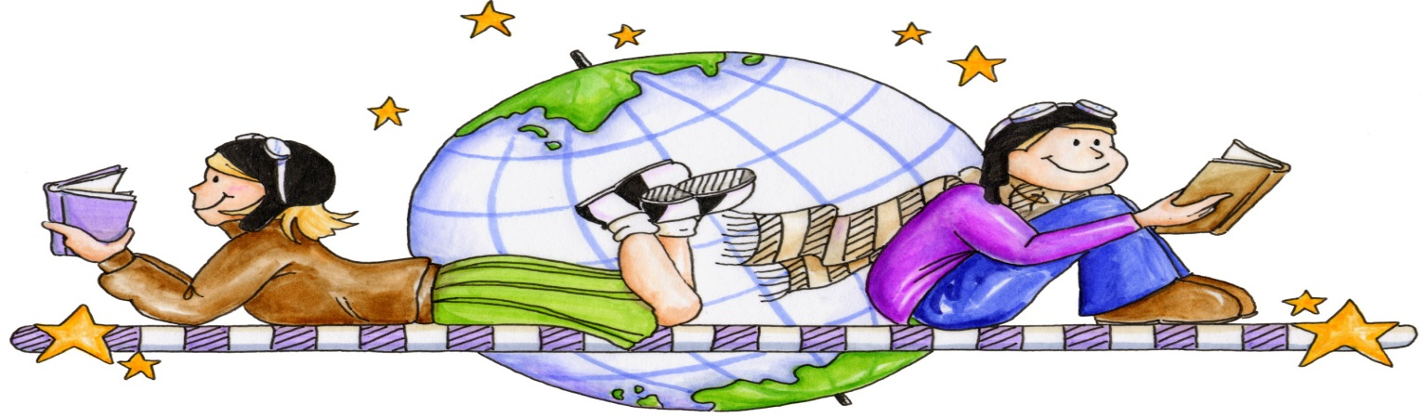 This is my **favorite** part!