You will have a book report due during each marking period. You may choose to read a book from any genre you like, but one must be non-fiction and you may not read the same genre twice. Each book you choose must be at or above your reading level and something you have not read before. Please have your books approved by me before deciding to use them for your book report assignments. I am also happy to make suggestions!

For each book report, you will have to compose a written report and prepare an oral presentation. The guidelines for each component are described below.

ORAL PRESENTATION GUIDELINES
Each student must prepare a 7-10 minute oral presentation about their book. The purpose of these presentations is to provide a forum for students to advertise their books to their peers.
- Presentations should include:
- A brief summary of the book (without giving away surprises or the ending)
- Some of the other reflections that were included in the written reports, especially things they most enjoyed about reading the book
- A critique of the book, including ratings and recommendations
- If possible, students should bring in a hard copy of the book to display.
- Students should also design a visual display for their presentation. Each marking period, students will be asked to do a different form of visual display. Options may include:
  - PowerPoint
  - Cereal Box Book report
  - Diorama
  - Advertisement
  - Pamphlet
  - Poster
  - Tri-fold
  - Other…Please get approved

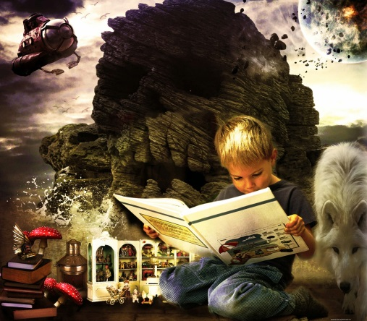

FICTION TEXTS

Summary: Each report must include a 1-2 page typed summary. The plot summary should include a description of all of the following:

- Setting (where, when, etc.)
- Important Characters
- Conflict (man v. man, man v. self, etc.)
- Exposition
- Rising Action
- Climax
- Falling Action
- Resolution

**Remember: The plot should always be discussed in the context of the conflict.**

Reader’s Response Questions: Please answer three of the questions from the list below. Be sure to answer each question in paragraph format.

- Favorite Scene: Describe in detail your favorite scene in the book. Be sure to describe the setting, including where and when this scene is taking place, and which characters are present. Also, explain why it is your favorite scene.
- Interesting Character: Describe a character from the story that you think is interesting. What character traits does this character possess that make him/her special? Name the character traits and give specific examples from the story.
- Recommendations: Please write a short critique of the book. Discuss whether or not you would recommend that others read it, and why. Also, identify what types of readers might enjoy this book the most.
- Alternative Scene: Please describe something that you would change about the story and write an alternative scene that reflects what you would change.

NONFICTION TEXTS

Summary: Each report must include a 1-2 page typed summary. The nonfiction summary should include important information from the text. This will vary depending upon thy type of text chosen. Often the “Table of Contents” may serve as a useful guide for how to structure this sort of summary.

Reader’s Response Questions: Please answer three of the questions from the list below. Be sure to answer each question in paragraph format.

- Significant Information: What is the most significant thing that you learned about this subject? What makes this information significant? Does it have an impact on the world? Does it impact the way you think or feel about something?
- Surprises: Describe in detail two things that surprised you in this book.
- Questions: Please identify three meaningful questions you still have about this topic. Then do some research and try to find answers to each of your questions. If you find answers, please list your sources. If you cannot find answers, please describe the process you used to look for the answers and what you learned during that process.
- Recommendations: Please write a short critique of the book. Discuss whether or not you would recommend that others read it, and why. Also, identify what types of readers might enjoy this book the most.

